Curriculum Vitae Europass |  | 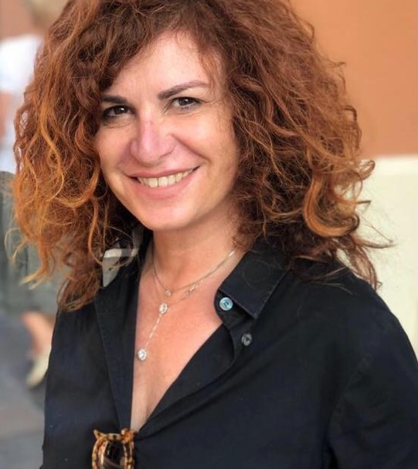
Personal information
Name(s) / Surname(s) |  | Stefania Ferretti M.D.
Address(es)
Fax
E-mail |  | ferretti.stefania@aou.mo.it  stefaniaferretti@icloud.com
Citizenship |  | Italian
Date of birth |  | 5th october 1966
Sex |  | F
Occupation /Professional sector |  | Since 1998: Medical Official I level framework Urology –2000-2022: Adjuvant Professor for urological teaching in Nephrology and Geriatric Care postgraduate schools; 2010-2019: Obstetrics, Oncology and Rehab Medicine; 2015-6/2022 Adjuvant Professor for Interventional Urology integrated course at 3° year of Medical School in University of Parma. Since 6/2022 to day: Adjuvant Professor 5° yrs -School of Urology at University of Modena and Reggio Emilia UNIMORE; 2/2022 Certificate of National Scientific Qualification (ASN) for Associate Professor of Urology  From june 2017 to june2022: Head of SS Endourology and Less Invasive Percutaneous Surgery - O.U. Urology - Hospital and University of Parma, Italy; from 6/2022 today: Head of Endourology and Minimally Invasive Surgery (LAp\Rob) at UO Urology of Azienda Ospedaliero-Universitaria of Modena; BAggiovara Hospital (Modena - Italy) – Coordinator of Prostate Cancer Unit at Hospital and University of Modena.
Professional Experience |  | 1/1998 to 10/2000 Medical Official I level at Urology O.U. of Carpi (Modena), Italy; 10/2000 to 6/2022 Case Manger Expert (senior Consultant) at Azienda Ospedaliera-Universitaria of Parma, Italy. 2006-2021: Tutor/evaluator for medical profession board examinations for the National Committee Medical Qualification. 2005-6/2022: Consultant for Se.pri.va group (www.vasculiti.it) for surgical managment of Idiopathic Retroperitoneal Fibrosis.  Faculty/Surgeon Operator for Endourological courses in Parma in 2006-2007-2008-2009-2015-2017,2018; Faculty/surgeon operator for International Endourology courses in Saragoza (Spain) in 2007, 2008.  Faculty/Operator for Laparoscopic oncological techniques courses in Parma 2014, 2015, 2016, 2017,2018,2019  Faculty/Moderator > 90 national and international congresses  Live surgery Operator in 42 national and international events (e.g. recent ones EAU 2022, EAU 2023, SIUlive 2022, Siulive 2021)  Attended courses: 7/2006: Advanced Course on Laparoscopic Upper Urinary Tract surgery– Ecole Europeenne de Chirurgie-Paris. Attendance at Laproscopic Urology Masterclass - 2008 Elancourt (France). 6/2009: Urological laparoscopic Surgery - Hospital Sacco in Milan (Italy). 11/2017 in Verona: Course training in robotic radical prostatectomy and simulation.
Date |  | Outset as Medical Official I level in 1998 at Hospital of Carpi (MO) and moving in October 2000 to Urology O.U. Azienda Ospedaliero-Universitaria of Parma (Italy) since 6/2022. Then change job place on 6/2022 to Azienda Ospedaliera Universitaria of Modena – Hospital and University of Modena, Italy
Activities and positions held
Endourology – Oncology – Laparoscopy – Pediatric urolithiasis
2017-2021 Member of the board of the directors: Italian Society of Endourology – IEA www.ieanet.it; since 2017 coordinator of Educational training committee in laparoscopy (IEA); Reviewer for Journal of Endourology; Minerva Nephrology and Urology; World Journal of Urology; Clinical Medicine Journal; Member of Editorial Board Urology of Minerva Nefphrology and Urology from 1/2023. (IF 5.14)
Coordinator of ECIRS working group – IAU – International Alliance of Urolithiasis (www.IAUnet.org), member of Video-relive group in Italian Urology Society-SIU (www.Siu.it);
From 7/2017 to 8/2019: Tutor for laparoscopic Teaching of Radical Prostatectomy at Urology Unit – Civil Hospital of Guastalla, Reggio Emilia, Italy
Education and Training |  | Autor of 131 printed publications; 240 scientific communications; autor of 3 Urology textbooks; 4 monographs; 2 contributions to translation english-italian of international scientific Urology textbooks.
Expertise and personal skills |  | Expert in Endourology - Urolithiasis in adult and children – complications and management in kidney transplantation (Endourological resolutions)– Senior consultant for prostate, kidney and urinary bladder cancer (laparoscopy and open surgery) surgical management – Trainee in Robotic Surgery – Management and surgical resolution of Retroperitoneal Fibrosis
First Language |  | Italian
Other Language |  | English
Self-evaluation |  |  | Comprehension |  |  |  | Spoken |  |  |  | Written
European Level(*) |  |  | Listening |  | Reading |  | Oral interaction |  | Oral production
Language |  |  |  | Good |  | Good |  | Good |  |  |  | Good
 |  | (*) Quadro comune europeo di riferimento per le lingue
Expertise and organizational skills |  | 3/2015 Degree: Management course for Health Authority Managers– Certificate of Attendance from Economy Faculty – University of  Parma, Italy
Expertise and E-skills |  | Use of the programs Word-Windows-POWERPOINT – Mac for Windows - Excel

 | Autorizzo il trattamento dei miei dati personali ai sensi del Decreto Legislativo 30 giugno 2003, n. 196 "Codice in materia di protezione dei dati personali (facoltativo)".
Firma | 30th March 2023

